

Applications of Vector Spaces in
1)Post Quantum Cryptography
2) Principle Component Analysis

Course: Linear Algebra
Semester: 03 (BS – CIS)
Date: December 20, 2025

Tasks Division
Task 01 -- Javeria Khan
Task 02 -- Abeera Anwar
Task 03 -- Dur e Adan
Task 04 -- Tuba Islam
Task 05 -- Ayesha Sajjad

Task 01

Vector spaces are an abstract concept in linear algebra that abstractly capture the geometry and algebra of linear equations.
A vector space is made up of four components:
- a set (V) of vectors
- a field (F), which is a set of numbers called scalars
- vector addition (represented by +) &
- scalar multiplication (represented by •)
In vector addition, vectors in the vector space are added together. In scalar multiplication, vectors in the vector space are multiplied by scalars. One of the most basic example of a vector space is the Euclidian space, which deals with two- or three-dimensional vectors.
Vector spaces play a crucial role in several important fields, especially:
- Data Science & Artificial Intelligence, where data points are represented as vectors in high-dimensional vector spaces.
- Cryptography & Security, where algebraic structures based on vector spaces are used to design secure encryption systems.
This project focuses on two important applications of vector spaces:
- Principal Component Analysis (PCA) an application of vector spaces in data analysis, where data is treated as vectors in a high-dimensional space and transformed into a lower-dimensional vector space using concepts such as basis vectors, span, and eigenvectors.
- Post-Quantum Cryptography an application of vector spaces in security, where cryptographic schemes rely on operations in high-dimensional vector spaces and lattices to ensure resistance against quantum computer attacks.

Introduction to Post-Quantum Cryptography (PCQ)
The quantum apocalypse is approaching. We therefore need to urgently look for quantum-safe alternatives to some of the current crypto methods.
Anyone interested in information security currently has to deal with post-quantum cryptography i.e. cryptographic methods that withstand a quantum computer.
Imagine that a hacker could access millions of online bank accounts and make transfers at will. Assume that the same hacker is able to read all encrypted emails that fall into his hands. And, in addition, imagine that this criminal person would be able to penetrate almost any corporate network in order to spy on it.
An unrealistic scenario? Not at all, because that’s exactly how it could turn out if one day there are powerful quantum computers. Because these devices can be used to crack the Rivest-Shamir-Adleman (RSA) and Diffie-Hellman methods, two crypto methods that are used billions of times in web browsers, e-mail clients, smartphones and ATMs. The digital apocalypse would become reality.
Fortunately, we’re not there yet. Although quantum computers already exist, they can so far only decompose smaller numbers into their factors. To threaten RSA or Diffie-Hell- man, they would have to manage a similar operation with a 700-digit number. They won’t be able to do that today or tomorrow.
But numerous experts are currently conducting intensive research on quantum computers and ensuring constant improvements so the apocalypse is drawing closer. We must therefore look in good time for alternatives to RSA and Diffie-Hellman that are not vulnerable to quantum computers. Such methods do exist, and they are grouped under the term “postquantum cryptography.”



How is encryption used today?
Encryption has been used for centuries to protect information. During World War II, the Enigma machine encrypted German messages, which could only be decoded with the correct key.
Today, encryption secures emails, internet connections, and digital communications. Modern methods like the Advanced Encryption Standard (AES) work similarly: data can only be read by someone with the correct key.
AES and Enigma are examples of symmetric encryption, where the same key is used for both encryption and decryption, and the sender and receiver must agree on the key in advance.
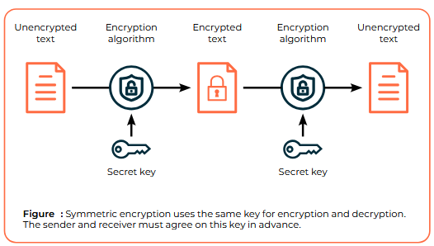
What is Asymmetric Cryptography?
Asymmetric cryptography is a method that uses two keys:
- Public key: anyone can use it to encrypt a message for the owner.
- Private key: only the owner can decrypt messages encrypted with their public key.
This solves the key exchange problem of symmetric encryption, where both sender and receiver needed the same secret key. Asymmetric cryptography also enables digital signatures, allowing a sender to sign a message with their private key, which anyone can verify using the public key.


How do RSA and Diffie-Hellman work?
RSA and Diffie-Hellman are examples of asymmetric cryptography.
RSA works by using a public key for encryption and a private key for decryption, based on the fact that multiplying two very large prime numbers is easy, but factoring their product back into the original primes is extremely hard.
Diffie-Hellman allows two parties to securely agree on a shared secret key over an insecure channel, using a one-way mathematical function called the discrete logarithm.
Both methods are currently secure against classical computers but could be broken by powerful quantum computers, which is why Post-Quantum Cryptography is needed.
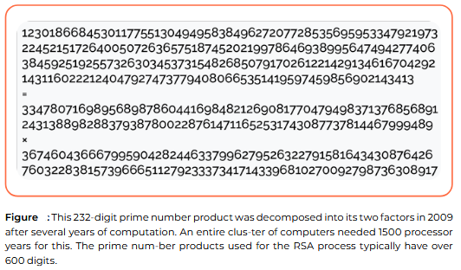
What is a quantum computer?
A quantum computer is a type of computer that uses quantum bits (qubits) instead of classical bits. Unlike classical bits, which can be either 0 or 1, qubits can exist in both states simultaneously due to quantum mechanics. This allows quantum computers to perform many calculations in parallel, making them extremely powerful for certain tasks, such as searching large databases or solving specific mathematical problems much faster than conventional computers. However, they can only output one result at a time, so they are not suitable for tasks that require processing the entire dataset sequentially.
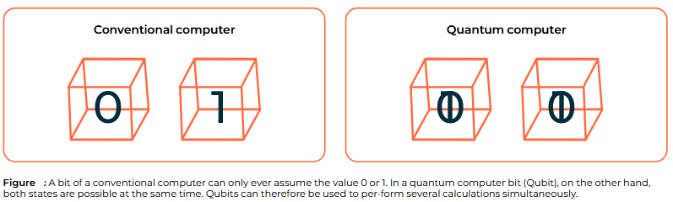

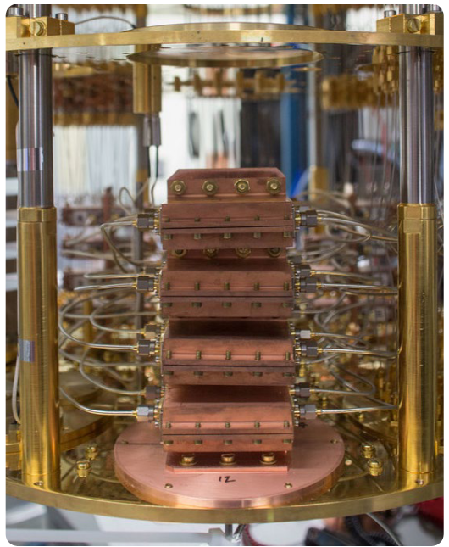
What encryptions can be solved with quantum computers?
Quantum computers can efficiently solve certain asymmetric encryption algorithms, such as RSA and Diffie-Hellman, because they can factor large numbers or solve discrete logarithm problems, which are the mathematical foundations of these methods. This poses a threat to online banking, secure
communications, and other systems that rely on these algorithms. Symmetric encryption, like AES, is less vulnerable. Quantum computers could theoretically weaken AES, but only for smaller key sizes (e.g., 128 bits). Using longer keys, such as 192 or 256 bits, keeps AES practically secure even against powerful quantum computers.

What is Post-Quantum Cryptography?
Post-Quantum Cryptography (PQC) refers to cryptographic methods that are secure against attacks by quantum computers. Unlike RSA and Diffie-Hellman, which could be broken by large-scale quantum computers, PQC uses alternative mathematical problems that are currently considered hard even for quantum machines. Many PQC methods exist, but most are still experimental and require further study before they can replace classical encryption in practice. The main goal is to eventually replace vulnerable algorithms like RSA and Diffie-Hellman with quantum-safe alternatives.
Bridge Between Post-Quantum Cryptography and PCA
While Post-Quantum Cryptography uses vector spaces to secure communication and protect against quantum attacks, Principal Component Analysis (PCA) applies vector spaces to analyze and simplify data. In PCA, high-dimensional data points are represented as vectors and transformed into a lower-dimensional space using concepts like basis vectors and eigenvectors. This shows that vector spaces are not only foundational for security but also for data analysis, connecting both applications through the same mathematical framework.
------------------------------------------------------------------------------

Task 03

Learning With Errors (LWE) and Python Visualization:

Introduction to Learning With Errors (LWE)
Learning With Errors (LWE) is a fundamental problem used in Post-Quantum Cryptography (PQC). It is built entirely on linear algebra concepts, yet remains computationally hard to solve, even for quantum computers.
LWE operates in a finite-dimensional vector space, where public vectors, secret vectors, and small error terms are combined using inner products, vector addition, and scalar multiplication. The addition of noise converts an otherwise solvable linear system into an approximate or inconsistent system, making exact recovery of the secret vector infeasible. This makes LWE resistant to both classical and quantum attacks, which is why it is widely used in modern PQC schemes.

Mathematical Explanation of LWE (Linear Algebra Level)
Let:
- a ∈ ℤⁿ be a known vector
- s ∈ ℤⁿ be a secret vector
- e ∈ ℤ be a small random error (could be noise or other factor)

The LWE equation is:
Where:
- ⟨a, s⟩ is the inner product
- e is a small perturbation

Key Idea:
- Without error (that is e = 0), the system is easy to solve
- With error (that is e ≠ 0), recovering s becomes hard
This aligns with our course topics:
- Inner product
- Vector spaces
- Orthogonality (noise breaks exact alignment)
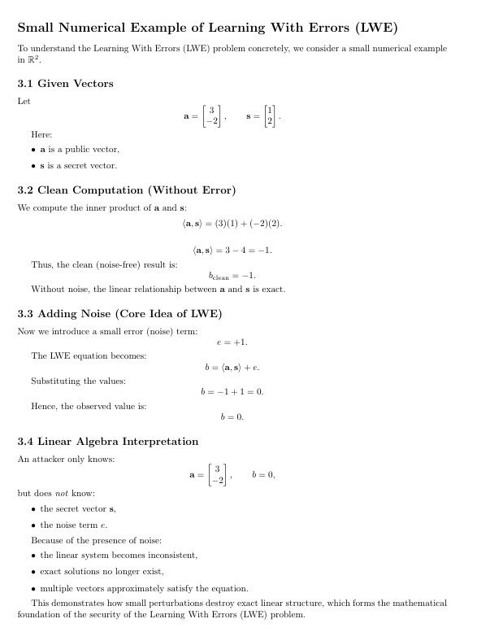
- Linear transformations

Relation with Lattices
A lattice is a discrete subset of ℝ² (or ℝⁿ) generated by integer linear combinations of basis vectors.
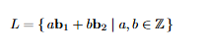
If b₁ and b₂ are basis vectors, then every lattice point is:
LWE can be visualized as:
- A clean lattice structure
- A point slightly shifted due to noise
This shift makes exact decoding difficult.

Python Implementation:

Step 1 : Lattice Generation
Two basis vectors were selected:
b1 = np.array([2, 1])
b2 = np.array([1, 3])
Using integer combinations, lattice points were generated:
points = []
for a in range(-4, 5):
for b in range(-4, 5):
points.append(a * b1 + b * b2)
This visually represents a discrete vector space, which is essential for lattice-based cryptography.

Step 2 :Clean and Noisy Computation
A secret vector s and a public vector a were defined:
a = np.array([3, -2])
s = np.array([1, 2])
The clean inner product was computed:
clean = np.dot(a, s)
Noise was added:
noise = np.random.randint(-1, 2)
noisy = clean + noise
This simulates the Learning With Errors principle.

5. Visualization Explanation
The following were plotted:
- Lattice points
- Basis vectors
- Clean result
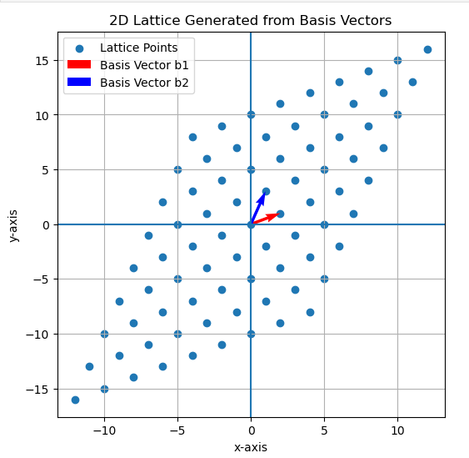
- Noisy result

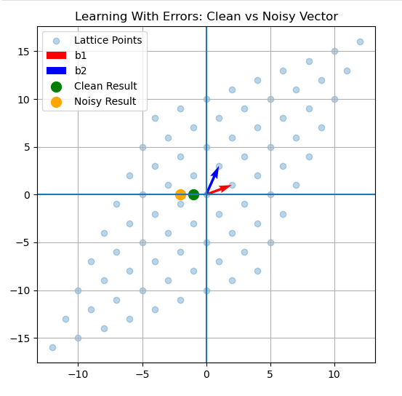

Interpretation:
- Green point → exact linear result
- Orange point → noisy result
- Small noise makes inversion unreliable
This demonstrates how even a small error hides the true structure, which is the security foundation of LWE.

Noise Makes Recovery Hard:
From a linear algebra perspective:
- Noise breaks exact linear relationships
- Systems become inconsistent
- Exact solution does not exist
- Approximation becomes computationally hard
In higher dimensions, this difficulty increases exponentially.

Use Cases of LWE in PQC
LWE is used in:
- Post-Quantum Encryption (CRYSTALS-Kyber)
- Key Exchange Protocols
- Digital Signatures (CRYSTALS-Dilithium)
These systems rely on the hardness of solving noisy linear equations over lattices.

Conclusion
This work demonstrated:
- Theoretical understanding of LWE
- Linear algebra foundation
- Practical visualization using Python
- How noise ensures cryptographic security
The visualization connects abstract mathematics to real-world cryptographic applications.

Principal Component Analysis & Post Quantum Cryptography
Task 04:
PCA Abstract
PCA Abstract Principal Component Analysis (PCA) represents a fundamentethnique in multivariate statistics and machine learning for dimensionality reduction through opltmeal transformationsThis report provides a comprehensive mathematical exposition of PCA, elucidating its geometric interpretation as a basis transformation in vector spaltes. systematically derive PCA from first principleb,eginning with mean centering and covariance computatiorproceeding through eigendecompositiond culminating in dimensionality reduction.The theoreticalframework is applied to Fisher's Iris dataset, where we demonstrate that two principdmponents capture 97.8% @lfe total variance, effectively reducing dimensionality from 4 to 2 dimensioMathematicalverification confirms orthogonality œfigenvectors ( $\overline{V}V=I$ with error $8.88×{10}^{-16}$ ) and validates the eigenvalue equation ( $Σv=λv$ with maximum error $4.44×{10}^{16}$ ). We analyze computationadomplexity ( $O\left(mn^{2}+n^{3}\right)$ ), discuss practicalapplications across domains,and examine limitations. The report bridges theoreticalinear algebra with practical implementation,roviding Python code, visualizationşnd comparative analysis with alternative methods.
Keywords: Principal Component Analysis, Dimensionality Reduction, Eigen decomposition, Covariance Matrix, Linear Algebra, Machine Learning, Iris Dataset
1 Introduction
1．1 Background and Motivation
In the era of big data，high－dimensional datasets present significant challenges for analysis， visualization，and computationaefficiency．The curse of dimensionality－where data becomes sparse in high－dimensiorsplaces－necessitates techniques for dimensionality reduction．Principal Component Analysis（PCA），pioneered by Karl Pearson in 1901 and later formalized by Harold Hotelling in 1933，stands as one of the most fundamental and widely used techniques for this purpose．
PCA finds applications across diverse domains：
Computer Vision：Eigenfaces for facial recognition
Finance：Portfolio optimization and risk analysis
Genomics：Gene expression data analysis
Natural Language Processing：Document topic modeling
Quality Control：Process monitoring and fault detection
1．2 Problem Statement
Given multivariate data with potentially correlated features，problems that arise are, how do we ：
1．Reduce dimensionality while preserving maximum information？
2．Identify underlying patterns and structures？
3．Transform data into an uncorrelated coordinate system？
4．Enable effective visualization of high－dimensional data？
1.3 Objectives
This part of Project/research aims to：
1．Provide a comprehensive mathematical exposition of PCA
2．Implement PCA from first principles on a real dataset
3．Interpret results both mathematically and contextually
4．Verify theoretical properties through empirical validation
5．Evaluate the trade－off between dimensionality reduction and information preserva－ tion
2 Mathematical Foundations of PCA
2.1 Vector Space Preliminaries
Consider a dataset with $m$ samples and $n$ features represented as matrix $X^{∧}∈G$
$$X=\left[\begin{matrix}x_{11} & x_{12} & ... & x_{1n} \\ x_{21} & x_{22} & ... & x_{2n} \\ .... & .... & .... & ... \\ x_{m1} & x_{m2} & .... & x_{mn}\end{matrix}\right]\left[\begin{matrix}x_{1}^{T} \\ x_{2}^{T} \\ ....x_{m}^{T}\end{matrix}\right]$$
Each row $x^{⊤}∈R^{n}$ represents a data point in an $n$-dimensional vector spæcthe Iris dataset: $m=150$ samples, $n=4$ features.
2.2 Mean Centering: Translating to Origin
2.2.1 Step 1: Compute Mean Vector
$$\begin{aligned}μ={\frac{1}{m}}_{i=1}^{χ^{m}}x_{i} \\ (2)\end{aligned}$$
For Iris dataset:
$$\begin{aligned}μ=\left[5.8433,3.0573,3.7580,1.19\overline{93}\right] \\ (3)\end{aligned}$$
2.2.2 Step 2: Center the Data
$$\begin{aligned}X_{\text{centered }}=X-1_{m}μ^{⊤} \\ (4)\end{aligned}$$
where $1_{m}$ is an $m×1$ vector of ones. This translation ensures the data cloud is centered at the origin.
2.3 Covariance Matrix: Capturing Data Shape
The covariance matrix $Σ∈R^{∝n}$ captures pairwise feature relationships:
$$\begin{aligned}Σ=\frac{1}{m-1}X_{\text{centered }}^{⊤}X_{\text{centered }} \\ (5)\end{aligned}$$
For the Iris dataset ( $m-1=149$ ):
$$\begin{aligned}Σ=\left[\begin{matrix}0.6858 & -0.0424 & 1.2743 & 0.5163 \\ -0.0424 & 0.1897 & -0.3297 & -0.121ϕ \\ 1.2743 & -0.3297 & 3.1163 & 1.2956 \\ 0.5163 & -0.1216 & 1.2956 & 0.5808\end{matrix}\right] \\ (6)\end{aligned}$$
2.3.1 Matrix Elements Interpretation
- Diagonal $Σ_{ii}=Var\left(x_{i}\right)=varianceoffeature$ $i$
- Off-diagonal $\sum_{ij}{}=Cov\left(x_{i},x_{j}\right)=covariancebetweenfeatures$ $i$ and $j$
2.3.2 Key Properties
- Symmetry: $Σ^{⊤}=Σ\left(\right.$ since $\left.Cov\left(x_{i},x_{j}\right)=Cov\left(x_{j},x_{i}\right)\right)$
- Positive Semi-Definite: All eigenvalues $λ≥0$
- Trace Represents Total Variance: $Tr(Σ)={}^{P}{}_{i=1}^{n}λ_{i}$
For Iris: $Tr(Σ)=0.6858+0.1897+3.1163+0.5808=4.5726$
2.4 Eigendecomposition: Finding Principal Directions
The core mathematical operation solves the eigenvalue problem:
$$\begin{aligned}Σv_{i}=λ_{i}v_{i}\text{ for }i=1,2,…,n \\ (7)\end{aligned}$$
where:
« $λ_{i}=i$-th eigenvalue (scalar, $λ≥λ_{2}≥⋯≥λ_{n}≥0$ )
« $v_{i}=i$-th eigenvector (unit vector, $‖M=1$ )
2.4.1 Matrix Formulation
$$\begin{aligned}ΣV=VΛ \\ (8)\end{aligned}$$
with:
$$\begin{aligned}V=\left[v_{1}\left|v_{2}\right|⋯h(n×n\text{ orthogonal matrix, }VVV=I)\right. \\ (9) \\ Λ=diag\left(λ_{1},λ_{2},…,λ_{9}\right)(n×n\text{ diagonal matrix }) \\ (10)\end{aligned}$$
2.4.2 Results for Iris Dataset
$$\begin{aligned}\text{ Eigenvalues }λ=\left[\begin{matrix}4.2282, & 0.2427, & 0.0782, & 0.0238\end{matrix}\right] \\ (11) \\ \text{ Eigenvectors. }V=\left[\begin{matrix}0.3614 & 0.6566 & 0.5820 & 0.3155 \\ -0.0845 & 0.7302 & -0.5979 & -0.319 \\ 0.8567 & -0.1734 & -0.0762 & -0.4798 \\ 0.3583 & -0.0755 & -0.5458 & 0.7537\end{matrix}\right] \\ (12)\end{aligned}$$
2.4.3 Verification
$$\begin{aligned}Σv_{1}-λ_{1}v_{1}={\left[4.44×{10}^{-16},-4.44×{10}^{16},0,8.88×{10}^{16}\right]}^{⊤}≈0 \\ (13)\end{aligned}$$
2.5 Projection: Dimensionality Reduction
2.5.1 Variance Explained Ratio
$$\begin{aligned}a_{i}=\frac{pλ_{i}}{\begin{matrix}n \\ j=1 \\ λ_{j}\end{matrix}} \\ (14)\end{aligned}$$
2.5.2 Cumulative Variance
$$\begin{aligned}C(k)=\frac{P_{k=1}^{k}λ_{j}}{\underset{j=1}{n}λ_{j}} \\ (15)\end{aligned}$$
2.5.3 For Iris Dataset
$$\begin{aligned}a_{1}=\frac{4.2282}{4.5726}=0.9246(92.46\text{\%}) \\ (16) \\ a_{2}=\frac{0.2427}{4.5726}=0.0531(5.31\text{\%}) \\ (17) \\ C(2)=\frac{4.2282+0.2427}{4.5726}=0.9777(97.77\text{\%}) \\ (18)\end{aligned}$$
2.5.4 Projection Matrix (selecting $k$ components)
$W=\left[\begin{matrix}v_{1} & \left|v_{2}\right| & ....... & .... & ... & \left|v_{k}\right|\end{matrix}\right](n×k$ matrix)
For $k=2:W=\left[v_{1}|v_{2}\right](4×2$ matrix $)$
2.5.5 Transformed Data
$$\begin{aligned}Z=X_{\text{centered }}W(m×k\text{ matrix }) \\ (20)\end{aligned}$$
First 5 transformed Iris samples:
$$\left[\begin{matrix}-2.6841 & 0.3194 \\ -2.7141 & -0.1770 \\ -2.8890 & -0.1440 \\ -2.7453 & -0.3183 \\ -2.7287 & 0.3268\end{matrix}\right.$$
Table 1: Variance Analysis Summary
Component | Eigenvalue ( $λ$ ) | Individual % Cumulative % |  | Interpretation
PC1 | 4.2282 | 92.46% | 92.46% | Dominant pattern (size)
PC2 | 0.2427 | 5.31% | 97.77% | Secondary pattern (proportio
PC3 | 0.0782 | 1.71% | 99.48% | Minor variations
PC4 | 0.0238 | 0.52% | 100.00% | Noise/random

3 Geometric Interpretation
3.1 Data as Points in High-Dimensional Space
The Iris dataset represents 150 points in a 4-dimensionalce,where each dimension corresponds to a morphological measuremeistalizing this directly is impossible for humans, but we can understand it mathematically as a "cloud" of points.
Original Coordinate System: Axes = {Sepal Length, Sepal Width, Petal Length, Petal Width}
3.2 Principal Components as Orthogonal Axes
PCA finds a new orthonormal basis $\left\{yv_{2},v_{3},v_{4}\right\}$ that optimally represents the data:
- $v_{1}$ : Direction of maximum variance (aligned with data's "longest" spread)
- $v_{2}$ : Next direction of maximum variance, orthogonal ${}_{1}$ to $v$
- $v_{3},v_{4}$ : Remaining orthogonal directions with decreasing variance
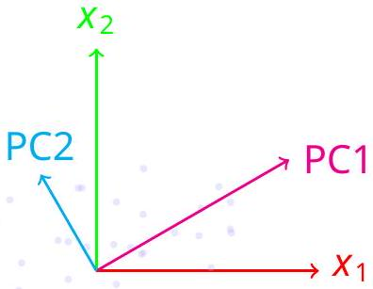
Figure 1: Geometric interpretatiorP.CA finds new orthogonal axes aligned with maximum data spread
Original axes in red/green Principal components in magenta/cyan
3.3 Variance Maximization Property
Mathematically, PC1 solves:
$$\begin{aligned}v_{1}=arg⁡\max_{‖v‖=1}\frac{v^{⊤}Σv}{v^{⊤}v} \\ (22)\end{aligned}$$
Since $‖v‖=1$, we can simplify to:
$$\begin{aligned}v_{1}=arg⁡ma{\underset{‖v‖=1}{v}}^{⊤}Σv \\ (23)\end{aligned}$$
This is the Rayleigh quotient maximization. Subsequent PCs solve the same optimization with additional orthogonality constraints:
$$\begin{aligned}v_{k}=arg⁡\max_{\begin{matrix}‖v‖=1 \\ v⊥\left\{v_{1},…,v_{k-1}\right\}\end{matrix}}v^{⊤}Σv \\ (24)\end{aligned}$$
Proof Sketch: By spectral theorem for symmetric matrices, eigenvectors of $Σ$ maximize the quadratic form™.
3.4 The Concept of Explained Variance
Explained variance quantifies how much information (variability) each principal component captures:
$$\begin{matrix} λ_{i}=\text{ absolute variance along }PCi \\ a_{i}={λ_{i}}/{\sum{}λ_{j}=\text{ proportion}\text{ of total variance }} \\ C(k)=\sum{a_{i}}=\text{ cumulative variance explained }\end{matrix}$$
The sharp drop in eigenvalues (scree plot) indicates where additioradmponents contribute little additional information.

4 Case Study: Iris Dataset Analysis
4.1 Dataset Description
Source: Fisher, R.A. (1936). "The use of multiple measurements in taxonomic problems" Samples: 150 (50 per species)
Features: 4 morphological measurements (all in cm)
« Sepal Length (SL)
- Sepal Width (SW)
« Petal Length (PL)
- Petal Width (PW)
Classes: 3 iris species (Setosa, Versicolor, Virginica)
Table 2: Iris Dataset Statistics
Feature | Mean | Std Dev | Min | Max | Unit
Sepal Length | 5.843 | 0.828 | 4.3 | 7.9 | cm
Sepal Width | 3.057 | 0.436 | 2.0 | 4.4 | cm
Petal Length | 3.758 | 1.765 | 1.0 | 6.9 | cm
Petal Width | 1.199 | 0.762 | 0.1 | 2.5 | cm

4.2 Step-by-Step Computation
4.2.1 Step 1: Data Loading and Inspection
import numpy as np
from sklearn.datasets import load_iris
# Load dataset
iris = load_iris ()
X = iris.data # Features (150 x 4)
y = iris.target # Labels
feature_names = iris.feature_names
target_names = iris.target_names
Listing 1: Loading Iris Dataset
4.2.2 Step 2: Mean Centering
$$\begin{aligned}X_{\text{centered }}=X-1_{150}μ^{⊤} \\ (25)\end{aligned}$$
where $μ=$ 993]
4.2.3 Step 3: Covariance Matrix Computation
# Manual computation
m = X.shape [0]
X_centered = X - np.mean (X, axis =0)
Sigma = (X_centered.T @ X_centered) / (m - 1)
# Result
Sigma = [[ 0.6858 -0.0424 1.2743 0.5163]
[ -0.0424 0.1897 -0.3297 -0.1216]
[ 1.2743 -0.3297 3.1163 1.2956]
[ 0.5163 -0.1216 1.2956 0.5808]]

4.2.4 Step 4: Eigendecomposition
# Compute eigenvalues and eigenvectors
eigenvalues, eigenvectors = np.linalg.eigh(Sigma)
# Sort in descending order
idx = np.argsort(eigenvalues)[::-1]
eigenvalues = eigenvalues [idx]
eigenvectors = eigenvectors [:, idx]
# Results
eigenvalues = [4.2282, 0.2427, 0.0782, 0.0238]
Listing 3: Eigendecomposition
4.2.5 Step 5: Variance Analysis
Table 3: Variance Explained Analysis
PC | Eigenvalue | Individual % | Cumulative % | Biological Meaning
PC1 | 4.2282 | 92.46% | 92.46% | Overall flower size
PC2 | 0.2427 | 5.31% | 97.77% | Sepal vs petal proportion
PC3 | 0.0782 | 1.71% | 99.48% | Minor shape variations
PC4 | 0.0238 | 0.52% | 100.00% | Measurement noise

4.3 Visualization of Results
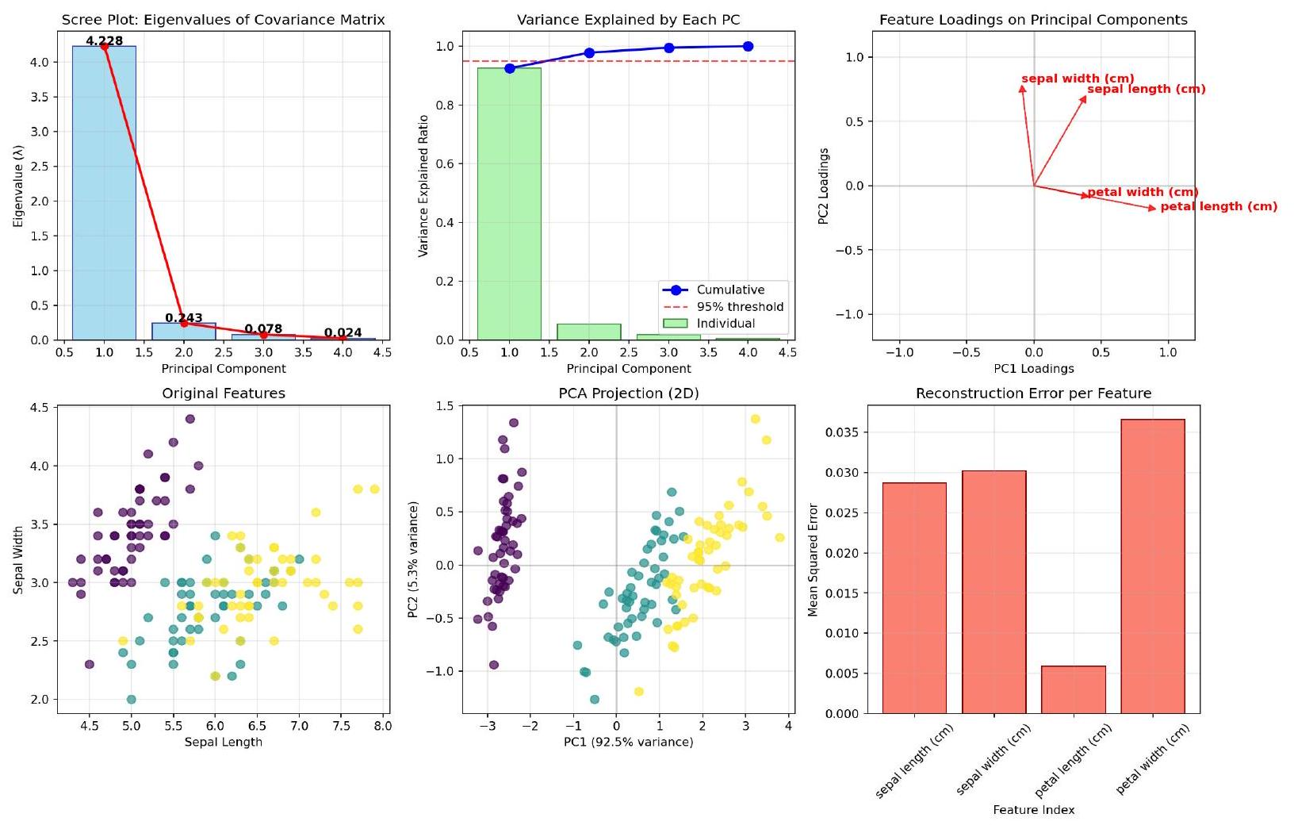
Figure 2: PCA Visualizations for Iris Dataset
4.4 Interpretation of Principal Components
4.4.1 PC1 (92.5% variance): Size Component
$$\begin{aligned}PC1=0.3614×SL-0.0845×SW+0.8567×PL+0.3583×PW \\ (26)\end{aligned}$$
Interpretation:
Dominant loading: Petal Length (0.8567) - strongest contributor
Positive contributions: Sepal Length (0.3614), Petal Width (0.3583)
Negative contribution: Sepal Width ( -0.0845 ) - slight inverse relationship
Biological meaning: Represents "overall flower size" gradient
Species separation: Setosa (small, negative PC1) vs Virginica (large, positive PC1)

4.4.2 PC2 (5.3% variance): Proportion Component
$$\begin{aligned}PC2=0.6566×SL+0.7302×SW-0.1734×PL-0.0755×PW \\ (27)\end{aligned}$$
Interpretation:
Dominant loadings: Sepal Width (0.7302), Sepal Length (0.6566)
Negative loadings: Petal Length (-0.1734), Petal Width (-0.0755)
Contrast: Sepal dimensions vs Petal dimensions
Biological meaning: Represents "sepal-to-petal proportion"
Species variation: Captures shape differences independent of size
4.4.3 Biological Insights
Table 4: Species Characterization in PCA Space
Species | PC1 Range | PC2 Range | Interpretation
Setosa | -4.0 to -2.0 | -1.0 to 1.0 | Small flowers, varying proportions
Versicolor | -1.0 to 1.0 | -1.5 to 0.5 | Medium flowers, specific proportions
Virginica | 1.0 to 2.5 | -1.0 to 1.5 | Large flowers, characteristic shape

5 Implementation Details
5.1 Algorithm Complexity Analysis
5.1.1 Time Complexity
Mean Centering: $O(mn)$ - linear in data size
Covariance Matrix: $O\left(mn^{2}\right)$ - dominates for large $m$
Eigendecomposition: $O\left(n^{3}\right)$ - dominates for large $n$
Projection: $O(mnk)$ - linear in all dimensions
Total Complexity: $O\left(max\left(mn^{2},n^{3}\right)\right)$
5.1.2 Space Complexity
Data Storage: $O(mn)$ for original data
Covariance Matrix: $O\left(n^{2}\right)$
Eigenvectors: $O(nk)$ for $k$ components
Projected Data: $O(mk)$
Total Complexity: $O\left(max\left(mn,n^{2}\right)\right)$
5.2 Numerical Stability Considerations
5.2.1 Condition Number
The condition number of covariance matrix :
$$\begin{aligned}K(Σ)=\frac{λ_{max}}{λ_{min}} \\ (28)\end{aligned}$$
For Iris dataset: $k={4.2282}/{0.0238}≈177.6$
5.2.2 Floating-Point Precision
- Double precision (64-bit):2.22 $×{10}^{-16}$ machine epsilon
- Our verification errors $8.88×{10}^{-16}$ (near machine epsilon)
- Well-conditioned for numerical stability
5.2.3 Alternative: Singular Value Decomposition (SVD)
More numerically stable approach:
$$\begin{aligned}X_{\text{centered }}=USV{}^{⊤} \\ (29)\end{aligned}$$
where:
V contains principal components (right singular vectors)
S diagonal matrix of singular values $\left(s^{p}\overline{(m-1)λ_{i}}\right)$
U contains standardized principal component scores
5.3 Comparison with SVD Approach
Table 5: ComparisonEigen decomposition vs SVD for PCA
Aspect | Eigendecomposition | SVD
Input Matrix | $$Σ=\frac{1}{m-1}X^{⊤}X(nO\overset{¨}{n})$$ | X centered (m×n)
Computational Cost | $O\left(n^{3}\right)$ for eigendecomposition | O(min $\left(m^{2}n,mn^{2}\right)$ )
Numerical Stability | Less stable for ill-conditioned matrices | More stable, handles rank  deficiency
Memory Usage | Stores n x n covariance matrix | Stores m x n data matrix
Implementation | Direct on covariance matrix | On centered data matrix

5．3．1 Python Implementation Comparison
# Method 1: Eigendecomposition
def pca_eigen (X, k):
X_centered = X - np.mean (X, axis =0)
Sigma = (X_centered.T @ X_centered) / (X.shape [0] - 1)
eigenvalues, eigenvectors = np.linalg.eigh(Sigma)
idx = np.argsort(eigenvalues)[::-1]
W = eigenvectors [:, idx [: k ]]
Z = X_centered @ W
return Z, W, eigenvalues[idx]
# Method 2: SVD
def pca_svd(X, k):
X_centered = X - np.mean (X, axis =0)
U,S,Vt = np.linalg.svd(X_centered, full_matrices = False)
W = Vt [:k, :].T
Z = U [:, :k] @ np.diag(S [: k ])
eigenvalues = (S **2) / (X.shape [0] - 1)
return Z, W, eigenvalues
Listing 4：Two PCA Implementations
6 Applications \＆Limitations
6．1 Practical Applications
6．1．1 Dimensionality Reduction
- Data Compression：Reduce storage requirements（50\％reduction for Iris）
- Visualization：Project high－D data to 2D／3D for human interpretation
- Noise Reduction：Remove components with small eigenvalues（noise）
6.1.2 Feature Engineering
Decorrelate Features：Create uncorrelated features for regression
Feature Selection：Identify most important original features
Multicollinearity Removal：For linear models with correlated predictors
6.1.3 Domain-Specific Applications
Table 6: PCA Applications Across Domains
Domain | Application | Brief Description
Computer Vision | Eigenfaces | Face recognition using PCA on facial images
Finance | Portfolio Optimization | Reduce risk factors to principal components
Genomics | Gene Expression | Identify patterns in high-D gene data
NLP | Topic Modeling | Latent Semantic Analysis using PCA
Signal Processing | Noise Filtering | Remove noise components

6.2 Assumptions and Limitations
6.2.1 Key Assumptions
- Linearity: PCA assumes linear relationships between variables
- Mean and Variance Sufficiency: Assumes mean and covariance adequately describe data distribution
- Large Variances Important: Assumes directions with largest variance are most important
- Orthogonality: Principal components are orthogonal (uncorrelated)
6.2.2 Limitations
- Scale Sensitivity: Results depend on feature scaling
- Outlier Sensitivity: Outliers can disproportionately influence principal directions
- Gaussian Assumption: Works best with multivariate Gaussian distributions
- Non-linear Patterns: Cannot capture non-linear relationships
- Variance not equal to Information: Important but low-variance features may be lost
6.3 Alternatives to PCA
6.3.1 Non－linear Dimensionality Reduction
Kernel PCA：Maps data to higher dimension where linear separation possible
t－SNE：Preserves local structure，good for visualization
UMAP：Preserves both local and global structure
Autoencoders：Neural network approach for non－linear compression
6.3.2 Feature Selection Methods
Filter Methods：Select features based on statistical tests
Wrapper Methods：Use model performance to select features
Embedded Methods：Feature selection during model training

Table 7：Comparison：PCA vs Alternative Methods
Method | Type | Strengths | Limitations
PCA | Linear | Fast，interpretable， decorrelates features | Cannot model non－linearity
Kernel PCA | Non－linear | Captures complex structure | Kernel choice， computationally heavy
t－SNE | Non－linear | Excellent visualization | Not suitable for downstream modeling
UMAP | Non－linear | Preserves local and global structure | Sensitive to hyperparameters
Autoencoders | Non－linear | Highly flexible | Requires large data，less interpretable

PCA Visualization, Comparison & Wrap-Up
1. PCA Visualization
Principal Component Analysis (PCA) helps us simplify complex, high-dimensional data by transforming it into a smaller set of new axes called principal components. This makes it easier to understand patterns in the data.
- PC1 (First Principal Component): Represents the main size pattern in the dataset.
- PC2 (Second Principal Component): Shows the proportion between different features, for example, sepal versus petal dimensions.
- Clusters: When we plot the first two principal components, the different species of the Iris dataset can be clearly distinguished.
Vector Space Concept: The principal components are like a new set of perpendicular directions in the data space. This helps in reducing dimensions while keeping the important patterns.
Takeaway: Visualization using PCA makes it easier to see patterns that are hard to notice in the original, high-dimensional data.

2. PCA vs Post-Quantum Cryptography (PQC) — Comparison
Aspect | PCA | PQC / LWE
Goal | Reduce dimensions, simplify data | Secure communication, resist quantum attacks
Math Used | Linear algebra, eigenvectors, covariance | Vector spaces, lattices, inner products, noise
Vector Space Role | Project data onto new perpendicular axes | Combine secret + public vectors + noise in lattice space
Result | Smaller, easier-to-understand data | Strong encryption that is hard to break
Visualization | Can plot in 2D or 3D | High dimensions are abstract; lattices can be drawn conceptually
Use Cases | Machine learning, finance, genomics | Post-quantum encryption, key exchange, digital signatures
Key Idea: Both PCA and PQC rely on vector space concepts.
- In PCA, vector spaces are used to simplify and visualize data.
- In PQC, small errors or noise are added to make it very hard for attackers to recover the secret.
3. Conclusion
- PCA helps reduce data size while keeping important information.
- PQC uses similar mathematical ideas to protect data from quantum attacks.
- Both PCA and PQC show how vector spaces can be applied in real life—one for data analysis, the other for security.
4. Future Scope
For PCA:
- Use advanced methods like Kernel PCA or Autoencoders for non-linear data.
- Apply PCA to real-time streaming data for dynamic analysis.
For PQC:
- Implement lattice-based encryption in real-world applications.
- Make quantum-safe cloud services more accessible and common.
Connecting PCA & PQC:
- Use PCA-like techniques to visualize high-dimensional lattices.
- Explore quantum-safe machine learning that uses vector space concepts for better security and data analysis.

References:
- Lecture Notes — Linear Algebra (Vector Spaces & Inner Products)
- Oded Regev, On Lattices, Learning with Errors, Random Linear Codes
- NIST Post-Quantum Cryptography Project (Lattice-based Cryptography)

